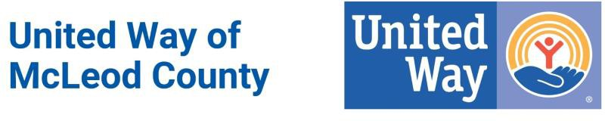

UWMC 2020 Community Small Grant

Timeline
- Application Open: Monday, April 27, 2020 at 12:00 pm
- Application Closed: Friday, May 22, 2020
  - If the application is sent by mail, it must be post marked by May 22, 2020.
  - If the application is sent by email to connect@unitedwaymcleodcounty.org, it must be sent by 5:00 p.m. on May 22, 2020. Email is the preferred method.
  - Please note that due to the COVID-19 pandemic, the UWMC office is not regularly staffed. Please do not bring the application to the office. Email is preferred, with mail as a secondary option.
- Notification of Grants Awarded: Friday, June 26, 2020
- First Disbursement of Funds (50%): Monday, August 3, 2020
- Second Disbursement of Funds (50%): Monday, February 1, 2021

Checklist
- Application (see attached)
- Project Budget (see attached)
- Latest Financial Statement
- Most Recent Audit Report and/or 990 Form
- 501(c)3 or Government Organization Certificate
- List of Board of Directors
- Copy of By-Laws

Updates

- There will be NO in person presentation required for the 2020 Community Small Grant Application (this may change for upcoming grants). If there are questions about your organization’s application, our Small Grant Committee may contact you via phone or email.
- Although your organization may apply for multiple grants for different programs, UWMC will only be awarding one grant per organization, per fiscal year.

Contact Information:
Questions? Please contact United Way of McLeod County.

Sara Waibel, Board President
connect@unitedwaymcleodcounty.org

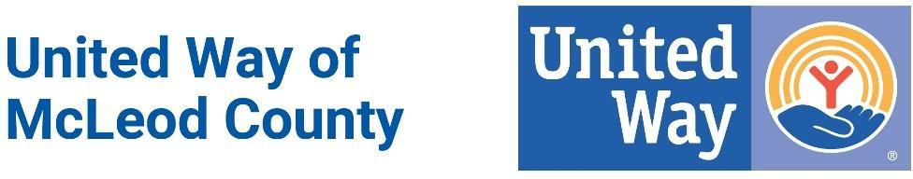

UWMC 2020 Community Small Grant Application Guidelines

Open: Monday, April 27, 2020 at 12:00 pm
Closed: Friday, May 22, 2020 at 5:00 pm

United Way of McLeod County is pleased to announce the 2020 Community Small Grant Application opportunity.
United Way of McLeod County (UWMC) fights for the Health, Education and Financial Stability of every person in McLeod County. UWMC has set aside funding for use during the 2021 fiscal year (July 1, 2020 - June 30, 2021) to provide small grants to eligible nonprofit organizations in McLeod County. The intent of the Community Small Grant program is to provide support for community projects, programs or initiatives in need of a small, one-time grant that aligns with our Community Impact Priorities.

About Small Grants:
The Community Small Grant is an outreach of United Way’s Community Impact funding process. The available amount of grant dollars each year is subject to change. For fiscal year 2021, grants up to $3,000 will be awarded to organizations aligned with UWMC’s priority areas of Health, Education, and Financial Stability.

Allowable Uses of Funding
Community Small Grant allocations can be used for projects such as:
- emerging or unmet needs and/or to support innovative solutions to local issues;
- program work including planning, training and/or development;
- organizational capacity building including strategic planning, governance and other types of organizational planning and/or development activities; and/or
- community and/or human service work that includes volunteer participation.

Funding Guidelines
- Community Small Grants of up to $3,000 are available for qualified projects.
- One grant per organization, per fiscal year (July 1- June 30).
- Funding will support programs, projects or initiatives that have a clear alignment to UWMC Community Impact Priorities and serve people living within McLeod County.
- Funding may not support capital campaigns, event sponsorships or marketing.

Eligibility Requirements
Applying agencies must:
- operate as a non-profit 501(c)3 organization, a public school, a unit of government and/or have a fiscal sponsor;
- operate under written Articles of Incorporation and By-laws or other written documents or statutes that define the applicant’s purposes, membership, management and operation;
- operate on non-discriminatory basis in employment, recruitment of volunteers and delivery of services;
- demonstrate effective program performance and financial responsibility and accountability;
- operate or provide services within McLeod County. Grant funding is only for programs serving individuals living within the UWMC service area. (Glencoe, Hutchinson, Brownton, Plato, Winsted, Silver Lake, Lester Prairie, Stewart, Biscay)
- align with the UWMC Community Impact Priorities of Health, Education and Financial Stability.

Operating Guidelines
- Funds shall be used solely for the granted purpose.
- Funded activities shall commence in a timely manner and the expenditures shall cease within one year after receipt of the grant unless an extension is granted by UWMC. Funds not expended shall be returned to UWMC.
- Small Community Grants will be approved by the Board of Directors upon recommendations from the Small Grant Committee. Clarifying questions for applicants may be required.
- Funding requests may be denied for various reasons. Some may include: request does not align with the priorities of UWMC, the program serves individuals outside of McLeod County, or the application is not fully completed. UWMC has the right to deny funding and will communicate with applicants if their request has been denied.
- No Small Community Grant will be given for any purpose that would jeopardize the tax-exempt status of UWMC or the applicant organization.
- Grant recipients shall conspicuously acknowledge UWMC in all promotional materials, activities and programs funded with UWMC monies. Logos will be provided.
- Grant recipients shall submit a project performance report (form attached in application) and financial statement indicating actual use and the results (stories, etc.) of the Community Small Grant funds within 60 days of completion of project/program end date. Failure to do so may result in removal from consideration of future grant opportunities.

Deadline: Friday, May 22, 2020
- If the application is sent by mail, it must be post marked by May 22, 2020.
- If the application is sent by email, it must be sent by 5:00 p.m. on May 22, 2020.
  - PLEASE NOTE that email is preferred. Please do not bring the application to the UWMC office – there is very limited staffing during this time.

Contact Information:
For questions about this application, please contact United Way of McLeod County.

Sara Waibel, Board President
connect@unitedwaymcleodcounty.org

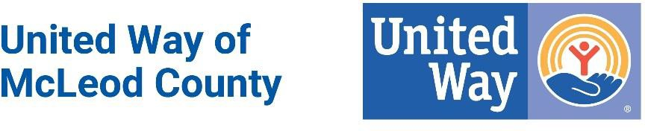

2020 Community Small Grant Application

Open: Monday, April 27, 2020
Closed: Friday, May 22, 2020

United Way of McLeod County’s (UWMC) 2020 Community Small Grant Application is an outreach of United Way’s Community Impact funding process. The available amount of grant dollars each year is subject to change. For 2020, grants up to $3,000 will be awarded to organizations aligned with UWMC’s priority areas of Health, Education and Financial Stability.

General Information
Name of Agency:
Name of Program:
Mailing Address:
Contact Person:
Title:

Email:

Phone Number:

Federal Tax ID Number:

Mission Statement
of Organization:

Please select the area your grant request addresses:

Health- Extend access to health care, health education and related services that will enable more people to live healthier lives.

Education- Making sure our children are prepared for school, supporting them through high school, and helping people of all ages gain skills to be successful in our communities.

Financial Stability- Supporting agencies that provide building blocks for a good life for individuals and families in McLeod County.

Amount Requested: $

List other co-sponsors of this proposal: (organization, contact person and telephone)

Proposal: On a maximum of two additional pages, describe the proposed project using the following format. Please number each section.

Identify what the request is for.

- Identify why you need the funds.

- Identify target population.

- State your program’s goals and objectives.

- Describe how this funding will help achieve your goals and objectives. How do you plan to measure the success of your program?

- Please describe your long-term plans/goals. How will you continue to implement and fund this program for the next 3 to 5 years?

- Describe any program or agencies that currently exist which provide similar services to the residents in McLeod County.

- List collaborative efforts with other community organizations (public, private, non-profit, etc.).

In addition to the application and proposal, please submit ONE (1) copy of the following:
  - Total Budget for Project (form attached)
  - Latest Financial Statement
  - Most Recent Audit Report and/or 990 Form
  - 501(c)3 or Government Organization Certificate
  - List of Board of Directors
  - Copy of By-Laws

Deadline: Friday, May 22, 2020
- If the application is sent by mail, it must be post marked by May 22, 2020.
- If the application is sent by email, it must be sent by 5:00 p.m. on May 22, 2020.
  - PLEASE NOTE that email is preferred. Please do not bring the application to the UWMC office – there is very limited staffing during this time.

Applications sent by mail should be addressed to:
United Way of McLeod County Community Small Grant Application PO Box 504
Hutchinson, MN 55350

Applications sent by email should be sent to:

connect@unitedwaymcleodcounty.org

Contact Information:
For questions about this application, please contact United Way of McLeod County.

Sara Waibel, Board President
connect@unitedwaymcleodcounty.org

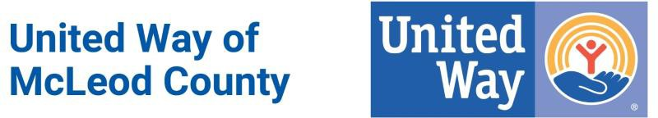

UWMC 2020 Community Small Grant

Budget for Project

Name of Organization Applying:

Describe budget for this proposal, not sponsoring organization(s)

Revenue:
Total: $
1. | $
2. | $
3. | $
4. | $
5. | $
6. | $

Expenses:

1. | $
2. | $
3. | $
4. | $
5. | $
6. | $
7. | $
 | Total:

Is there a charge for service provided by this project or activity?

Prepared by: Title: Date:

END PROJECT REPORT*
Only to be filled out by Community Small Grant recipients
within 60 days after the completion of the project.

Project Title:
- Number of people involved in the planning and/or execution of this project:

- Number of people who attended/benefited from this project:

- Describe the project:

- Did you accomplish what you set out accomplish? Do you consider this project a success?

- What could have been done differently?

- What changes happened because of this project?

- How do you intend to continue this project or similar projects in the future?

- How did you give recognition to UWMC for funding your project?

- Name, email and phone number of Contact Person:

Please submit at least THREE (3) photographs with approval for UWMC to use the photos.

Yes, the THREE photos submitted are available for the use of UWMC.

If more space is required, please attach a file addressing each section above

Return Completed Report to:
United Way of McLeod County, PO Box 504, Hutchinson, MN 55350
OR
connect@unitedwaymcleodcounty.org

*United Way of McLeod County requires an End Project Report from each agency within 60 days of the project completion. Thank you!

